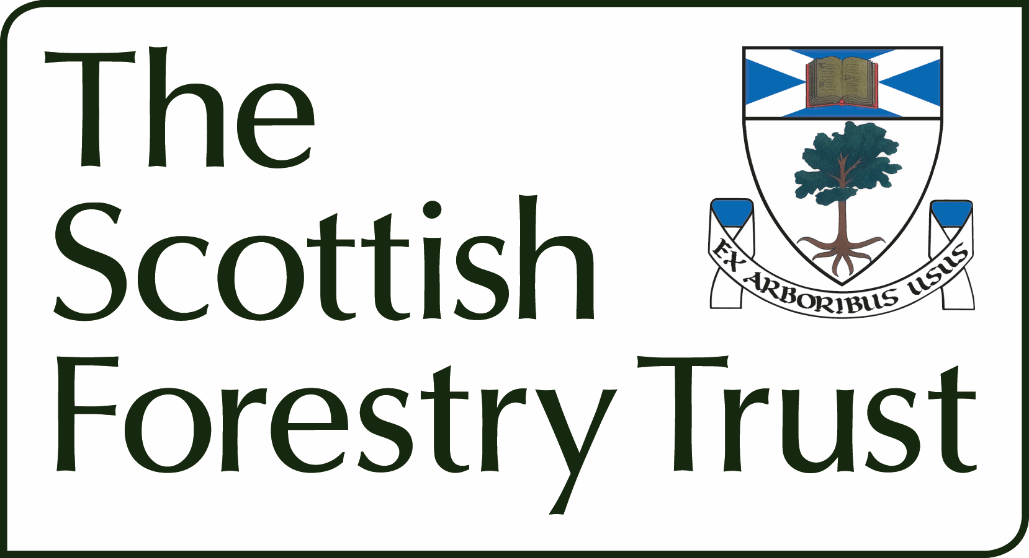

Application Form

Proof of Concept and Scoping Studies

Title of project (maximum 50 characters)

Objectives or research questions (maximum 50 words)

Short description of the purpose of the scoping work (maximum 300 words)

Explain how the scoping work will underpin future actions of interest to SFT (e.g. Intended topic area for a full application to the Trust (or other funding body)) (maximum 100 words)

Relevance to UK forestry (maximum 100 words)

Funding
 | £ | %
The Scottish Forestry Trust
Other sources
Total |  | 100
Name of applicant

Institution / organisation

Address of applicant

Tel.
Fax
Email:

Signature of applicant

Date:

This form should be sent to director@scottishforestrytrust.org.uk

